## **(ML) Programming Section 4: Plotting Data in MATLAB**

**You can also download all necessary files for this section at the following MATLAB Drive Link:**[**[CLICK HERE]**](https://drive.mathworks.com/sharing/fdc134e4-641e-4bce-8ee7-02e6822a6c58/)

## **Objectives**

* Philosophy of **visualization**
* **Plotting data**, creating some data dashboards
* Introduction to the **MATLAB AI** and **Data Science toolkits**

## **Main Learning Goal**

Develop familiarity with plotting and visualization techniques in the MATLAB environment. Apply knowledge of different visualization techniques to present data in an efficient and appropriate manner. Students will learn how to create, resize, label, and adjust plots to desired specifications.

## **Focus Question**

What is the best way for me to visually communicate my data in MATLAB?

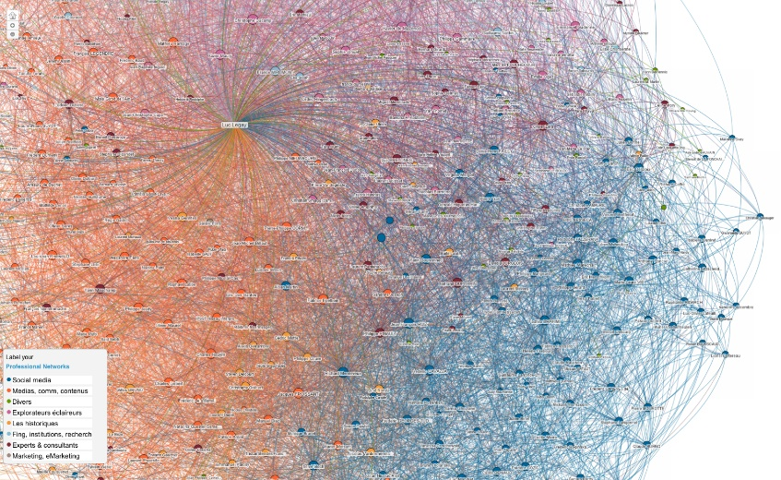

'[Linkedin maps data visualization](https://www.flickr.com/photos/luc/5418037955)' by [Luc Legay](https://www.flickr.com/photos/luc/with/44358931280) is licensed under [CC BY-SA 2.0](https://creativecommons.org/licenses/by-sa/2.0/)

## **Maps**

You may have heard there is no way to truly correct way to represent our Earth on a flat image. It is impossible to unwrap the spherical dimensions of the globe to perfectly portray the layout and shapes of our globe on a 2D surface. This has posed a fundamental challenge from the inception of their tradition. Mapmakers have had to decide what information to preserve and what information to distort to communicate the important information their maps need to convey. As a result, there are many **projections** or techniques of flattening the globe that have proven useful.

The Mercator projection is a popular map style for use in navigation. It represents lines of straight travel on a constant course, which proved useful for planning trips across the sea.  To convey course properly, the size of landmasses is greatly distorted. This is why Greenland is often mistaken for being over 500 times larger than it really is.

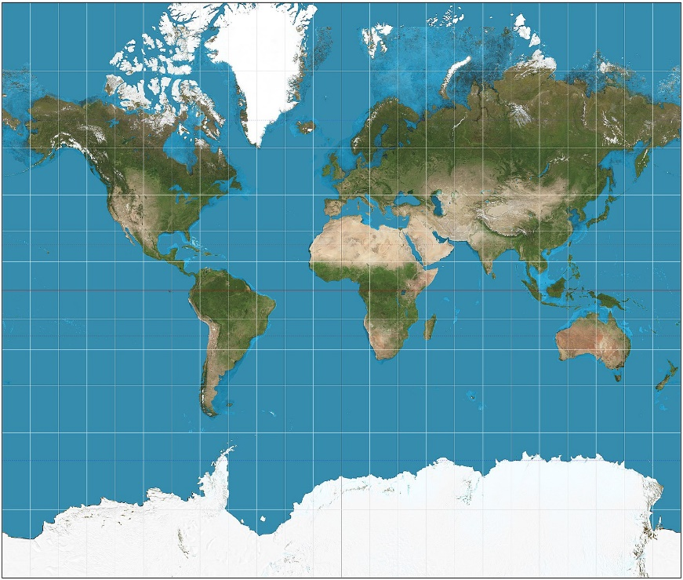

'[File:Mercator projection SW.jpg](https://en.wikipedia.org/wiki/File:Mercator_projection_SW.jpg)' by [Strebe](https://commons.wikimedia.org/wiki/User:Strebe) is licensed under [CC BY-SA 3.0](https://creativecommons.org/licenses/by-sa/3.0/deed.en)

Even the positioning of landmasses is a result of decisions made by the mapmakers. Europe might not have been positioned in the top-center if the mapmakers were raised somewhere else. There is no up or down or left or right in space, and these decisions do not represent objective truth.

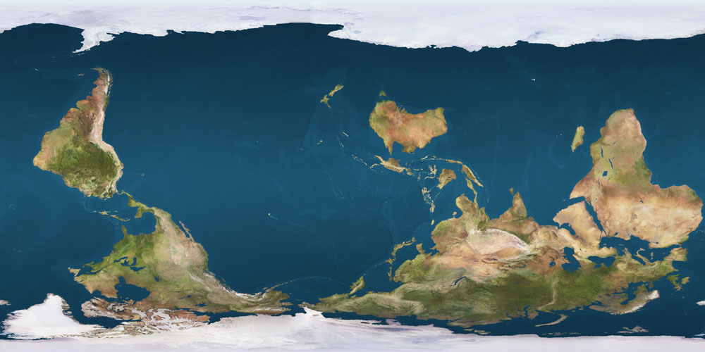

'[Reversed Earth map](https://commons.wikimedia.org/wiki/File:Reversed_Earth_map_1000x500.jpg?uselang=en#Licensing)' by [Poulpy](https://commons.wikimedia.org/wiki/User:Poulpy) is licensed under [Public Domain](https://en.wikipedia.org/wiki/Public_domain)

When we communicate data, we are -in a way- **mapmakers**, charting informational territory and placing emphasis on aspects of data we are trying to emphasize. This comes with a lot of decision-making and utilization of different techniques.

**Now search the web for different types of maps.**

***What do each of them emphasize or distort?***

**Plotting Data in MATLAB**

**Please copy over the files for Section 04 from the MATLAB Drive**

## The files can be found from the link given at the top of the handout: [**[CLICK HERE]**](https://drive.mathworks.com/sharing/fdc134e4-641e-4bce-8ee7-02e6822a6c58/)

For the first coding activity, please open “**ML_Sec04(Part 1) – Plotting Data.mlx**”

Please follow the examples along with the instructor or the PowerPoint PDF that can be found in the same folder as this section’s code in the MATLAB Drive. After completing this live script, please continue to Part 2.

**Popularity Plotting**

## The live script for this section can be found in the same MATLAB Drive folder as above: [**[CLICK HERE]**](https://drive.mathworks.com/sharing/fdc134e4-641e-4bce-8ee7-02e6822a6c58/)

For this section you can use the hints given and the PPT to complete the given problems on your own. If you need help, the teacher or teaching assistant will be able to walk through the problem with you.

Make sure to refer back to the previous live script if you are stuck on what code to use to solve a problem!

**Drawing Conclusions from the Data**

'[File:Scen 10 husbygardsskolan.jpg.](https://commons.wikimedia.org/wiki/File:Scen_10_husbygardsskolan.jpg)' by [Mays Josef](https://commons.wikimedia.org/w/index.php?title=User:Mays_Josef&action=edit&redlink=1) is licensed under [CC BY-SA 4.0](https://creativecommons.org/licenses/by-sa/4.0/deed.en)

**Let's think about the Lil Pump Popularity data we just analyzed:**

Compare the two plots created using the various popularity indices from the data file linked in the assignment.

**Knowing this, discuss and answer the following question in groups:**

1. What can we infer from these graphs?

***Hint: When may Gucci Gang have been released? When was Lil Pump at his peak popularity?***